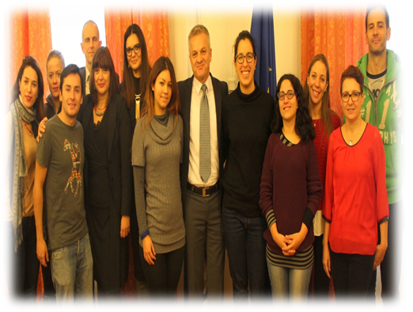
GUIDEBOOK FOR SCHOLARSHIP RECIPIENTS OF THE PROGRAMME FOR CROATIAN LANGUAGE LEARNING IN THE REPUBLIC OF CROATIA

STATE OFFICE FOR CROATS ABROAD

Contents
1. Introductory speech by State Secretary 3
2. What does scholarship for the programme of Croatian
language learning comprises 4
3. What needs to be done upon arrival in the Republic of Croatia 5
3.1. Signing the Agreement on awarding scholarship for learning Croatian language 6
3.2. Residence registration in the Republic of Croatia 6
3.3. Health insurance in the Republic of Croatia 8
4. Additional information 9
4.1. Issuance of student pass to be used for public transport 9
4.2. Acquiring Croatian citizenship 10
4.3. Recognition of foreign qualifications 11
4.4. Croatian Heritage Foundation 12
4.5. Tourist Boards 12
4.6. Information for students 13
4.7. List of student restaurants 13

- Introductory speech by State Secretary

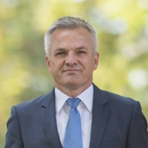
Dear descendants of Croatian expatriates,
It is a great honour and pleasure to greet you on behalf of State Office for Croats Abroad, all of you who were awarded the scholarship for learning Croatian language.
We appreciate your knowledge and awareness you have about the country of your origin as well as the readiness you expressed to come here in order to get familiar in the best possible way with Croatian language and culture, the language and culture of your ancestors.
Today when Croatia is an independent and sovereign country, our mutual bonds and cooperation are of special importance. One of the strategic goals of the Republic of Croatia and the task of this State Office is to strengthen Croatian communities abroad and their links with the homeland.
We pay special attention to preservation of Croatian identity, providing special care for all Croats and their descendants. Therefore, the preservation, studying and promotion of Croatian language is of utmost importance. Thus, we would like to make our mutual cooperation even closer and to encourage Croats abroad to return to the Republic of Croatia. Our biggest success should be togetherness and therefore we would like to carry out all programs and projects in full cooperation with you and Croatian communities all over the world.
The purpose of this guidebook is to provide assistance upon the arrival to Croatia and while attending the programme of Croatian language, so as to efficiently solve numerous difficulties that all those visiting a certain country for the first time are faced with. This mostly refers to the issues of administrative nature, that are stipulated by regulations and common procedures of various institutions and offices.
We have tried to include the issues that seem most important from our experience so far, but we would like to emphasise that State Office will always remain at your disposal for all individual needs and situations in public sphere in the Republic of Croatia.
In this respect I wish you a warm welcome and I believe that your stay in our beautiful homeland studying Croatian language and learning about Croatian culture will be productive, and to our mutual benefit and satisfaction.
I wish you a pleasant stay and life in the homeland.

State Secretary
Zvonko Milas

Programme of Croatian language learning in the Republic of Croatia aims at nurturing and preserving of Croatian language outside the Republic of Croatia and encouraging the return of emigrated Croats and their descendants to the Republic of Croatia. It enables all interested members of Croatian nation to study Croatian language and learn about the culture in the Republic of Croatia. Teaching models include extra-curricular activities in which students take an active part in order to learn the language and the culture in a practical way.

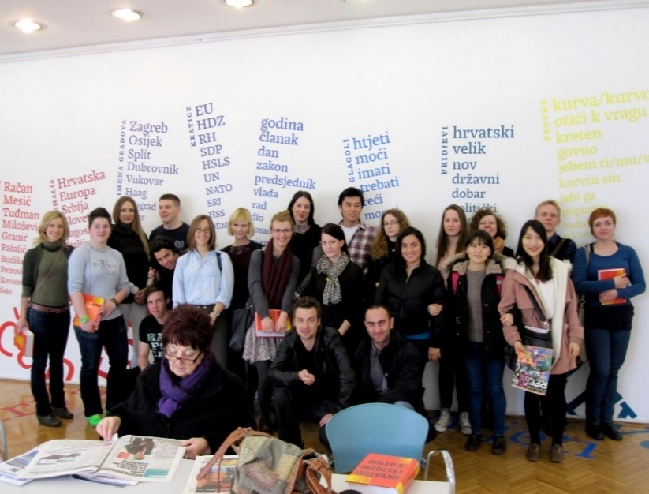

- What does scholarship for the programme of Croatian language learning comprises
By signing the agreement with the State Office, as scholarship provider, scholarship recipients gain certain rights and have certain responsibilities.

RIGHTS
For each scholarship recipient of the State Office for Croats Abroad the Office covers:
- course costs in the amount of HRK 4,500 per semester
- accommodation costs in the amount of HRK 300 per month
- costs of subsidised meals up to two meals per day
- costs of personal needs – pocket money – in the amount of 100 HRK per month

In order to fully exercise the right covering the costs stated, scholarship recipients must perform the following:

DUTIES
- attend classes regularly
- pass the final exam and
- inform the State Office about the change of residence or travel (e.g. each absence from the classes or student residence longer than 3 days and travel during the course)

- What needs to be done upon arrival to the Republic of Croatia
Upon arrival to the Republic of Croatia it is necessary to do the following:

STEP 1 – State Office for Croats Abroad
When signing the agreement with the State Office:
- take the signed agreement
- take the certificate of Course attendance
- take x-card (student card)

STEP 2 – Tax administration
It is necessary:
- to obtain a personal identification number (OIB)
http://www.porezna-uprava.hr/HR_OIB/Documents/zahtjev-OIB.pdf
Address of Tax administration – regional office Zagreb is Avenija Dubrovnik 32
Working hours: 8:00 - 15:00
It is necessary to bring a passport for inspection.

STEP 3– Ministry of the Interior
In competent police station or police administration:
- Register the residence in the Republic of Croatia

STEP 4 – Regulate health insurance
Regulate health insurance

Additional steps and information for the following areas are:
ADDITIONAL STEPS
- obtain student’s pass for public transport
- submit the request to obtain Croatian citizenship (Certificate of nationality and passport)
- initiate the procedure for recognition of foreign qualifications

ADDITIONAL CONTACTS AND INFORMATION
- Croatian Heritage Foundation
- Tourist Boards in the Republic of Croatia
- Information for students and
- List of student restaurants

3.1. Signing the Agreement on awarding scholarship for Croatian language learning
State Office scholarship recipients will get the notice about the date and time of signing the Agreement with the State Office. Upon signing the Agreement, the State Office scholarship recipients shall:

- Take the Agreement on allocating funds for Croatian language learning
- Take the certificate of course attendance for the purpose of residence application and
- Take X-card – card for subsidised meals

3.2. Residence registration in the Republic of Croatia

Upon arrival to the Republic of Croatia it is necessary to register the residence at the Ministry of the Interior in the following police stations or police administrations:

- ZAGREB - Petrinjska 30, Zagreb
- SPLIT - Trg Hrvatske bratske zajednice 9, Split
- RIJEKA - Žrtava fašizma 3, Rijeka
Scholarship recipients who stay at student residence need to:
- Obtain certificate of registered residence at student residence office
- Personally submit the request and enclose all necessary documents to a competent police station or police administration
- Obtain the card or residence certificate

Scholarship recipients who stay in private accommodation need to:
- submit the request and enclose all necessary documents to a competent police station or police administration
- obtain the card or temporary residence certificate

- Residence registration for PARTICIPANTS WITHOUT CROATIAN CITIZENSHIP
In order to obtain residence permit it is necessary to submit the relevant request, required documents and apply with all documents requested to a competent police station or police administration.

REQUEST FOR RESIDENCE REGISTRATION
- Fill in the request available at:
https://www.mup.hr/UserDocsImages/Dokumenti/stranci/Obrazac%201a.pdf
Note: for the purpose of stay write studying
- ispuniti zahtjev koji je dostupan na:
https://www.mup.hr/UserDocsImages/Dokumenti/stranci/Obrazac%201a.pdf
Napomena: za svrhu boravka u RH navesti studiranje

ADDITIONAL DOCUMENTS REQUIRED
- photocopy of valid travel document
- proof of provided means of subsistence (proof of awarded scholarship or proof of monthly means of subsistence in the amount of minimum HRK 1,000 which you will prove by enclosing a bank certificate for bank account)
- certificate of residence issued by student residence office for persons staying in student dormitories, landlord statement, approval of application for residence at the address of property (statement shall be certified by a notary public, the cost is about HRK 50,00) or lease agreement.
- proof of justified purpose of staying (certificate of the State Office as well as the certificate of attendance from Faculty of Humanities)
- proof of health insurance (more details under item 3.3.) and
- colour photo 35x45 mm

COST OF RESIDENCE REGISTRATION
Application fee for the temporary residence permit totals:
- duty stamp fee of HRK 20,00
- approval of temporary residence in the amount of HRK 500,00
- cost of issuance of biometric residence permit in the amount of HRK 240,00.
Note: the same amount shall be paid each time the temporary residence permit is extended.

After completed procedure a biometric residence card is issued as a proof of approved residence.

Note: Application for extended residence permit shall be submitted at least 60 days before your temporary residence permit expires.
- Residence permit application for PARTICIPANTS WHO ARE CROATIAN NATIONALS
For the purpose of obtaining residence permit it is necessary to fill in the relevant request, enclose the required documents and submit application with all the documents to a competent police administration or police station.
APPLICATION FOR ISSUANCE OF APPROVAL FOR TEMPORARY RESIDENCE
- fill in the form available at:
https://mup.hr/UserDocsImages/upute_obrasci/obrazac_1.pdf

ADDITIONAL DOCUMENTS REQUIRED
- photocopy of valid identification document (passport or identity card)
- certificate of residence issued by student residence office for scholarship recipients staying in student residence, and those who stay in private accommodation i.e. a rented flat it is necessary to submit certified landlord statement giving approval of residence registration at the address of property (statement shall be certified by a notary public, the cost is about HRK 50,00) or lease agreement.

Certificate is issued upon registration of residence.
Note: Croatian nationals are exempted from paying administrative fees for registration of residence.

3.3. Health insurance in the Republic of Croatia
Proof of health insurance is submitted with the application for residence permit at a competent police station or police administration (refers to item 3.2.). Health insurance regulation differs in the following three categories:
Citizens of EU, EEA and Switzerland should submit:
- European Health Insurance Card or other relevant certificate that regulates health insurance in line with current EU regulations.
By submitting one of the proofs stated above health insurance is considered regulated.

Citizens of the countries that have health care agreement with the Republic of Croatia should submit:
(Bosnia and Herzegovina, Macedonia, Serbia, Montenegro and Turkey)
- health insurance certificate of Croatian Health Insurance Fund, relevant certificate of foreign health insurance or other proof required by the social security agreement
By submitting one of the proofs stated above health insurance is considered regulated.

Citizens of the countries that do not have health insurance agreement with the Republic of Croatia (not included in the previous two groups)
- After the residence is approved (within 8 days) citizens should report to the competent branch office of Croatian Health Insurance Fund to establish the rights for compulsory health insurance according to the regulations on health insurance for foreign citizens in the Republic of Croatia.
- Fund then determines whether there is the obligation for the application for compulsory health insurance.
- In case Croatian Health Insurance Fund determines that a person is not entitled to health insurance the person must cover the insurance costs (the cost is HRK 5,000 for previous year and HRK 441 for each consecutive month.)

Health insurance may be regulated at the following addresses of Croatian Health Insurance Fund (HZZO):
ZAGREB:
- Margaretska ulica 3., tel: 01/4806 333,
- Jukićeva ulica 12., tel: 01/4882 100,
- Klovićeva ulica 1., tel: 01/4359 555
SPLIT:
- Obala Kneza Branimira 14, tel 021/408-900
RIJEKA:
- Slogin Kula 1, tel: 051/355-311

Detailed information on compulsory health insurance is available at http://www.hzzo.hr/.
- Additional information

  - Issuance of student pass to be used for public transport
In order to exercise the right for monthly student pass for public transport - tram or bus service - it is necessary to submit the following documents:
- Completed form for issuance of student pass
- Photocopy of student’s transcript or certificate of enrolment
- Photography certified at Faculty’s registry office
- photocopy of passport
- fee of HRK 30 for issuance of student pass

While topping up the pass you can purchase a monthly or annual pass depending on the amount you pay.
The cost of annual pass is HRK 1,200 and monthly pass is HRK 120.

Offices where student pass can be issued:
ZAGREB:
- Trešnjevka; Ozaljska 105, tel: 01/3651-555,
- Dubrava; Dubrava 1, tel: 01/2911-143,
- Donji grad - centar; Importane centar, tel: 01/4577-257
- Donji grad-Centar, Marićev prolaz : 01/ 4811-670,
RIJEKA:
Jelačićev trg 3, 051/7660-364
SPLIT:
Obala Kneza Domagoja 12, 021/338-469

Bus and tram timetables:
For public transport in Zagreb –timetable available at http://www.zet.hr/
For public transport in Rijeka – timetable available at http://www.buscroatia.com/hr/kolodvor-rijeka-autobusi/
For public transport in Split – timetable available at
http://www.ak-split.hr/HR/vozni.red/VozniRedOdlazaka.aspx

  - Acquiring Croatian citizenship
In case you decide to acquire Croatian citizenship during your stay in the Republic of Croatia you should contact the State Office which will provide help with the procedure.
Note: If you want to receive a certificate of registration in the Register of Croatian citizens in the Republic of Croatia you need to pay HRK 1,500 when receiving the certificate regardless of the fact that you paid a fee at a consular office. After being informed by competent officials you will take the certificate at the police station Zagreb, Petrinjska 30.

CERTIFICATE OF NATIONALITY
Certificate of nationality is an official document serving as proof of Croatian citizenship.
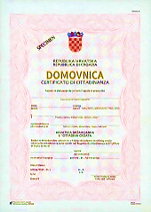
Upon receiving the certificate of registration in the Register of Croatian citizens, you can require nationality certificate at the General Register Office of the Town of Zagreb, Ilica 25.
Cost of fee is HRK 25.
PASSPORT
Passport is a public document also serving as proof of identity and Croatian citizenship, and is issued for unlimited number of trips abroad.
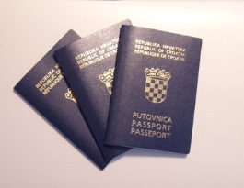
For urgent procedure of passport issuance it is necessary to do the following:
fill in the request and enclose:
- photo (for biometric passport) - 35 x 45 mm
- valid identification document or other document serving as proof of identity
- certificate of nationality

You should request passport issuance at the Ministry of the Interior.
Cost: HRK 410 for passport issuance and administrative fee of HRK 140.
Detailed information on passport issuance is available at http://www.policija.hr/44.aspx
  - Recognition of foreign qualifications
Croatian citizens, foreign citizens and persons without citizenship have the right to get their foreign education qualifications recognized.
Procedure for recognition of primary and secondary education qualifications:
Education and Teacher Training Agency (Donje Svetice 38, Zagreb) is competent for recognition of qualifications attesting the completion of primary education and general, grammar and art secondary school programmes for the purpose of employment or continuation of education.
Queries for recognition of foreign education qualifications may be sent on e-mail: iok@azoo.hr
Agency for Vocational Education and Training and Adult Education (Radnička cesta 38b, Zagreb) is competent for recognition of qualifications attesting the completion of vocational secondary education programmes (VET programmes) for the purpose of employment or continuation of education.
Department for recognition of foreign education qualifications
Email: inozemne.kvalifikacije@asoo.hr
Phone: + 385 1 6126 780
- Telephone queries about the recognition of foreign education qualifications are received only in the period from 2 p.m.to 4 p.m.
- reception of clients and providing information about the recognition of foreign education qualifications is possible in the office only on Monday in the period from 2 p.m. to 4 p.m.

Procedure for recognition of higher education qualifications and a period of study:
Croatian universities, polytechnics and colleges are competent for academic recognition and recognition of the period of study for the purpose of continuing education. are
Agency for Science and Higher Education is competent for professional recognition of higher education qualifications and periods of study for the purpose of employment
National ENIC/NARIC office, Donje Svetice 38, Zagreb

Recognition of specializations and professional examinations
Recognition of specializations and professional examinations is under the authority of:
Relevant ministry and professional organizations.

  - Croatian Heritage Foundation

Croatian Heritage Foundation prepares and organizes various cultural, sporting and other events for Croatian immigrant population.
One of its programmes is organization of summer schools of Croatian language. Programmes can be found on website www.matis.hr.
Contact for Zagreb: Trg Stjepana Radića 3,email: hmi-info@matis.hr; Tel: 01/ 6115- 116;
Contact for Rijeka: Trpimirova 6; email: rijeka@matis.hr; Tel: 051/ 214 557
Contact for Split: Marmontova 5, email: split@matis.hr; Tel: 021/321 904
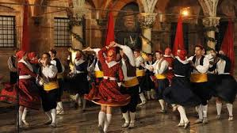
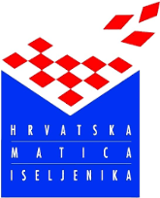

  - Tourist Boards
You should contact Tourist Board of a certain town to get information about events, organized trips/daily excursions in the Republic of Croatia.
- Zagreb Tourist Board, Kaptol 5, Zagreb
Tel: +385 1 48-98-555
website: www.tzgz.hr

- Split Tourist Board, Obala Hrvatskog narodnog preporoda 9, Split
Tel: +385 (0)21 348 600
website: www.visitsplit.com

- Rijeka Tourist Board, Užarska 14, Rijeka
Tel: +385 51 315 710
Note: In case you travel outside the Republic of Croatia during your stay in the Republic of Croatia you are obliged to inform the State Office for Croats Abroad.

  - Information for students

STUDENT CENTRE ZAGREB
http://www.sczg.unizg.hr/opci-podaci/
STUDENT CENTRE SPLIT
http://www.scst.unist.hr/
STUDENT CENTRE RIJEKA
http://www.scri.uniri.hr/
STUDENT ASSOCIATIONS
ZAGREB - http://www.mojfaks.com/studentske-udruge
SPLIT - http://www.unist.hr/studiranje-u-splitu/studentske-udruge
RIJEKA http://uniri.hr/index.php?option=com_content&view=article&id=1133&Itemid=221&lang=hr

Emergency call number (ambulance, police, fire department) – 112

  - List of student restaurants

ZAGREB
- Restaurant Cassandra, Unska 3
- Restaurant "SUPERFAKS", Pierottijeva 6
- Fast food restaurant „Bologna", Horvatovac 102a
- Fast food restaurant "Tekstilni", Pril. Baruna Filipovića 28a
- Restaurant Borongaj, Borongajska cesta
- Fast food restaurant at Faculty of Mechanical Engineering and Naval Architecture, Ivana Lučića 5
- Restaurant at Faculty of Agriculture, Svetošimunska 25
- Restaurant at Academy of Fine Arts, Ilica 85
- Restaurant at Faculty of Economics and Business, Trg J. F. Kennedyja 6
- Restaurant at School of Medicine , Šalata 3b
- Restaurant at Faculty of Veterinary Medicine , Heinzelova 55
- Restaurant Savska, Savska cesta 25
- Restaurant in Student residence "Cvjetno naselje", Odranska 8
- Restaurant in Student residence "Lašćina", Lašćinska cesta 32
- Restaurant in Student residence "Stjepan Radić", Jarunska 2
- Odeon" catering service Branko Babić, A. Kačića-Miošića

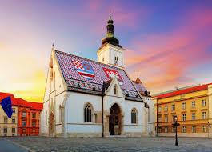

RIJEKA
- Bistro "PRAVRI", Hahlić 6
- Bistro "RITEH", Vukovarska 58
- Cafe bar "Infuzija", Viktora Cara Emina 5
- Cafe bar "Medicinar", Braće Branchetta 20
- Cafe bar "Kampus", Radmile Matejčić 5
- Restaurant Indeks, Krešimirova ul. 18
- Restaurant Mini, Čandekova ul. 4

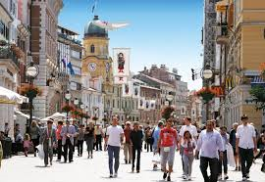

SPLIT
- Caffe bar "Kantun C", Šoltanska 2
- Dom "Bruno Bušić", Spinutska 37
- Hostel Spinut, Spinutska bb
- Restaurant at Faculty of Economics, Matice Hrvatske 31
- Restaurant at Faculty of Electrical Engineering, Mechanical Engineering and Maritime Architecture, Ruđera Boškovića bb
- Restaurant Faculty of Humanities, Radovanova 13
- Restaurant FPMZS-a, Teslina 12
- Restaurant at Faculty of Civil Engineering and Architecture, Matice Hrvatske 5
- Restaurant "Index", Svačićeva 8
- Restaurant at Faculty of Law, Domovinskog rata 8
- Student restaurant SKVUŠ

STATE OFFICE FOR CROATS ABROAD
WISHES YOU A PLEASANT STAY IN THE HOMELAND!
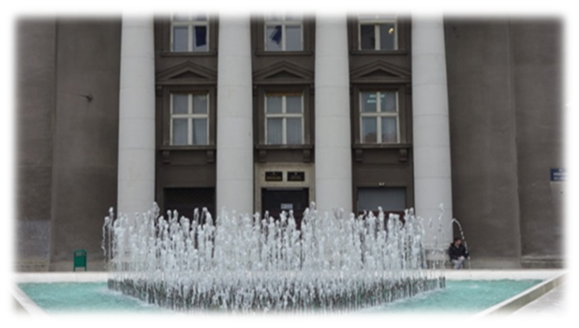
Trg hrvatskih velikana 6
10 000 Zagreb
Tel: +385 (01)6444 680
Fax: +385 (01) 6444 688
E-mail: ured@hrvatiizvanrh.hr
Web-site: www.hrvatiizvanrh.hr

Contacts:
Viktor Škovrlj - for all queries related to programme of Croatian language learning; tel: 01/6444-683; E-mail: vskovrlj@hrvatiizvanrh.hr
Marija Matek - for all queries related to status issues; tel: 01/6444-670; E-mail: mmatek@hrvatiizvanrh.hr

